1. **Write a Embedded C Program to Create a Weather Reporting System that provides real- time environmental data to users.**

**Code:**

#include <DHT.h> #include <Wire.h>

#include <LiquidCrystal_I2C.h>

#define DHTPIN 2

#define DHTTYPE DHT11

DHT dht(DHTPIN, DHTTYPE);

LiquidCrystal_I2C lcd(0x27, 16, 2);

void setup() { dht.begin();

lcd.init(); lcd.backlight(); lcd.setCursor(0, 0);

lcd.print("Weather Report");

}

void loop() {

float temp = dht.readTemperature(); float hum = dht.readHumidity();

if (isnan(temp) || isnan(hum)) { lcd.setCursor(0, 1); lcd.print("Error Reading"); return;

}

lcd.setCursor(0, 1); lcd.print("Temp: "); lcd.print(temp); lcd.print("C ");

lcd.print("Hum: "); lcd.print(hum); lcd.print("%"); delay(2000);

}

**Output:**

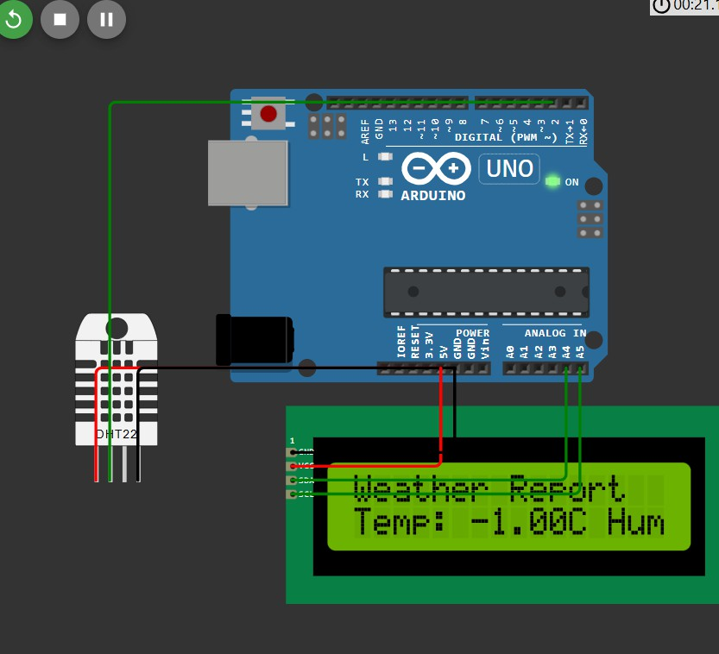

1. **Write a Embedded C Program to Create a Home Automation System that simplifies daily routines (Any 2 Devices) by controlling devices remotely.**

**Code:**

#define LED1 2

#define LED2 3

void setup() {

// Initialize the LEDs as outputs pinMode(LED1, OUTPUT); pinMode(LED2, OUTPUT);

// Start serial communication Serial.begin(9600);

Serial.println("Home Automation System"); Serial.println("Commands: "); Serial.println("1 - Turn on LED1 (Light 1)"); Serial.println("0 - Turn off LED1 (Light 1)");

Serial.println("2 - Turn on LED2 (Appliance 2)"); Serial.println("3 - Turn off LED2 (Appliance 2)");

}

void loop() {

// Check if data is available on Serial if (Serial.available()) {

char command = Serial.read(); // Read the incoming command

// Control LED1 (Light 1) if (command == '1') {

digitalWrite(LED1, HIGH); // Turn on LED1 Serial.println("LED1 is ON");

}

if (command == '0') {

digitalWrite(LED1, LOW); // Turn off LED1 Serial.println("LED1 is OFF");

}

// Control LED2 (Appliance 2) if (command == '2') {

digitalWrite(LED2, HIGH); // Turn on LED2 Serial.println("LED2 is ON");

}

if (command == '3') {

digitalWrite(LED2, LOW); // Turn off LED2 Serial.println("LED2 is OFF");

}

}

}

**Output:**

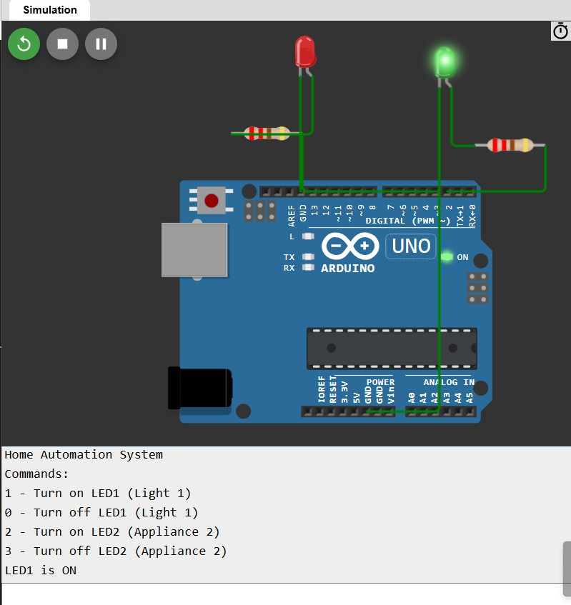

1. **Write a Embedded C Program to Create an Air Pollution Monitoring System that tracks air quality levels in real-time to ensure a healthier environment.**

**Code:**

#include <Wire.h>

#include <Adafruit_SSD1306.h> #include <Adafruit_GFX.h>

#define SSD1306_I2C_ADDRESS 0x3C // I2C address for OLED display

#define POT_PIN A0 // Analog pin for potentiometer #define BUZZER_PIN 8

#define LED_PIN 9

// OLED settings

#define SCREEN_WIDTH 128

#define SCREEN_HEIGHT 64

#define OLED_RESET -1 // No reset pin needed

Adafruit_SSD1306 display(SCREEN_WIDTH, SCREEN_HEIGHT, &**Wire**, OLED_RESET);

void setup() {

**Serial**.begin(115200);

// Set up Buzzer and LED pins pinMode(BUZZER_PIN, OUTPUT); pinMode(LED_PIN, OUTPUT);

// Initialize OLED

if (!display.begin(SSD1306_I2C_ADDRESS, OLED_RESET)) {

**Serial**.println(F("OLED allocation failed")); for (;;);

}

display.clearDisplay(); display.setTextColor(SSD1306_WHITE); display.setTextSize(2); // Increase text size for better visibility display.setCursor(0, 0);

display.print("Air Pollution Monitor"); display.display();

delay(2000);

}

void loop() {

int sensorValue = analogRead(POT_PIN);

float airQualityIndex = map(sensorValue, 0, 1023, 0, 500);

**Serial**.print("Air Quality Index: ");

**Serial**.println(airQualityIndex);

display.clearDisplay(); display.setCursor(0, 0); display.print("Air Quality Index:"); display.setCursor(0, 20); display.print(airQualityIndex); display.print(" ppm");

if (airQualityIndex > 300) { display.setCursor(0, 40); display.print("Warning: Poor Air Quality!"); digitalWrite(BUZZER_PIN, HIGH); digitalWrite(LED_PIN, HIGH);

} else { display.setCursor(0, 40);

display.print("Air Quality is Good"); digitalWrite(BUZZER_PIN, LOW); digitalWrite(LED_PIN, LOW);

}

display.display(); delay(1000);

}

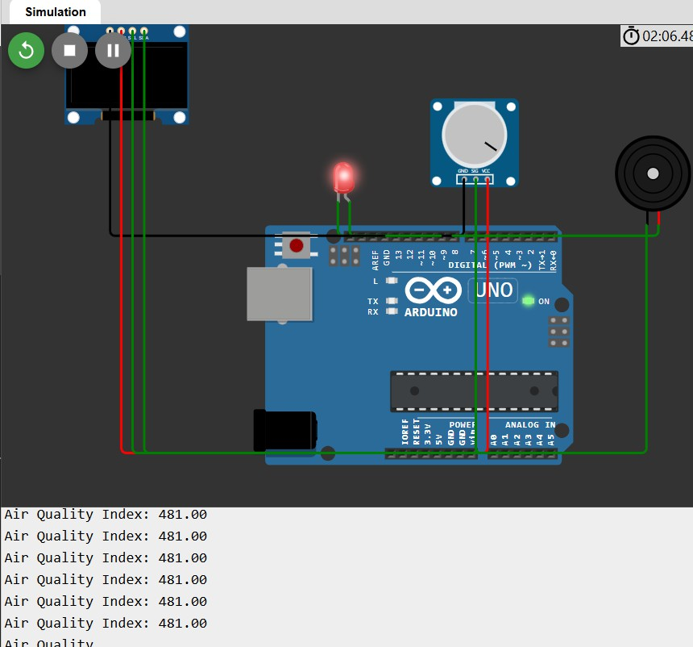**Output:**

1. **Write a Embedded C Program to Create an IoT-based Smart Irrigation System for Agriculture that automates watering based on weather and soil conditions.**

**Code:**

#include <DHT.h> // Include the DHT sensor library

// Define pins

#define SOIL_MOISTURE_PIN A0 // Analog pin for soil moisture sensor (Potentiometer)

#define DHT_PIN 2 // Digital pin for DHT11 sensor (simulated) #define RELAY_PIN 1 // Digital pin for relay (water pump)

// DHT sensor setup

DHT dht(DHT_PIN, DHT11); // DHT11 sensor on the specified pin

// Variables

int soilMoistureValue = 0;

float temperature = 30.0; // Simulate temperature of 30°C float humidity = 0.0;

bool isWateringRequired = false;

void setup() {

**Serial**.begin(115200); pinMode(RELAY_PIN, OUTPUT);

digitalWrite(RELAY_PIN, LOW); // Ensure relay is off at startup

// Initialize DHT sensor dht.begin();

}

void loop() {

// Read soil moisture (Potentiometer value) soilMoistureValue = analogRead(SOIL_MOISTURE_PIN); **Serial**.print("Soil Moisture: ");

**Serial**.println(soilMoistureValue);

// Simulate temperature (30°C)

temperature = 35.0; // Manually set temperature to 30°C for testing

// Print simulated temperature and humidity

**Serial**.print("Temperature: ");

**Serial**.print(temperature);

**Serial**.print(" °C | Humidity: ");

humidity = dht.readHumidity(); // Read humidity from DHT11

**Serial**.print(humidity);

**Serial**.println(" %");

// Logic for automatic irrigation: if soil is dry and temperature is high, water the plants if (soilMoistureValue < 400 && temperature > 30.0) {

isWateringRequired = true;

} else {

isWateringRequired = false;

}

// Control water pump (Relay) if (isWateringRequired) {

**Serial**.println("Watering plants..."); digitalWrite(RELAY_PIN, HIGH); // Turn on water pump

} else {

**Serial**.println("No need to water."); digitalWrite(RELAY_PIN, LOW); // Turn off water pump

}

delay(5000); // Wait before next reading

}

**Output:**

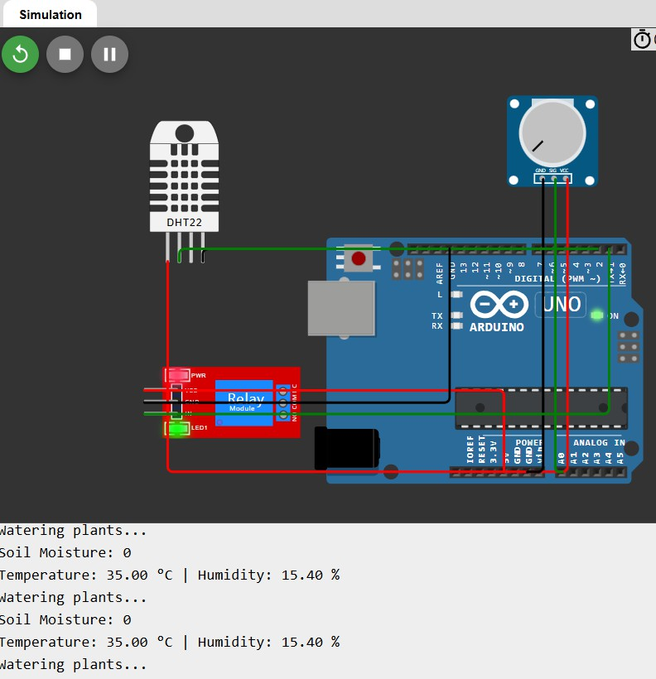

1. **Write a Embedded C Program to Create a Smart Alarm Clock that adjusts to your schedule and environment, waking you up intelligently.**

**Code:**

#define BUZZER_PIN 8 // Digital pin for buzzer #define LED_PIN 9 // Digital pin for LED

int airQualityIndex = 0; // Default value of air quality index

void setup() {

Serial.begin(115200); // Start serial communication for debugging

// Set up Buzzer and LED pins pinMode(BUZZER_PIN, OUTPUT); pinMode(LED_PIN, OUTPUT);

// Print initial message to Serial Monitor

Serial.println("Air Pollution Monitoring System Initialized"); Serial.println("Enter Air Quality Index (0-500): ");

}

void loop() {

// Check if data is available in Serial Monitor if (Serial.available() > 0) {

// Read the entered value airQualityIndex = Serial.parseInt();

// Ensure that air quality index stays within the range (0 - 500) if (airQualityIndex < 0) airQualityIndex = 0;

if (airQualityIndex > 500) airQualityIndex = 500;

// Print the entered air quality index to the Serial Monitor Serial.print("Air Quality Index: "); Serial.print(airQualityIndex);

Serial.println(" ppm");

}

// Logic to determine if air quality is good or poor if (airQualityIndex > 300) { Serial.println("Warning: Poor Air Quality!");

digitalWrite(BUZZER_PIN, HIGH); // Turn on the buzzer digitalWrite(LED_PIN, HIGH); // Turn on the LED

} else {

Serial.println("Air Quality is Good"); digitalWrite(BUZZER_PIN, LOW); // Turn off the buzzer digitalWrite(LED_PIN, LOW); // Turn off the LED

}

delay(1000); // Wait for 1 second before checking again

}

**Output:**

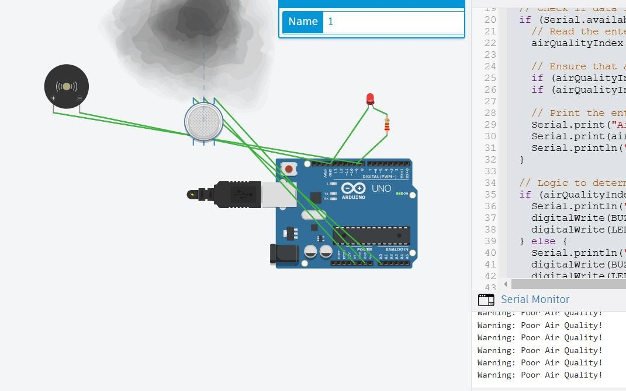

**Case Study:**

1. **Interface a Camera Module to create an Attendance Monitoring System of Your Class Room.**

**1.A:**

**IoT-Based Attendance Monitoring System Using Arduino Uno**

**Objective**

To develop an automated attendance monitoring system using Arduino Uno and a camera module, integrated with IoT for storing attendance data and providing real-time access to attendance records.

**Components Required**

**Hardware:**

1. Arduino Uno
2. ESP8266 Wi-Fi Module (for IoT connectivity)
3. OV7670 Camera Module
4. MicroSD Card Module (for local data storage)
5. Power Supply (5V)
6. Jumper Wires and Breadboard
7. LEDs (optional, for status indication)
8. Push Button (optional, for manual input)

**Software:**

1. Arduino IDE
2. Firebase (for cloud integration)
3. Face Recognition Software (Python script on a connected computer, if required)
4. Any serial communication tool (e.g., Serial Monitor or PuTTY)

**System Workflow**

1. **Image Capture**:
   * The OV7670 camera module captures images of students when they stand in front of the camera.
2. **Image Processing**:
   * Images are processed and stored locally on an SD card or sent to a computer for face recognition.
   * Arduino facilitates the communication between the camera and connected components.
3. **Attendance Marking**:
   * Recognized faces are matched with a pre-stored database of students.
   * Attendance is recorded in real time.
4. **IoT Integration**:
   * Attendance data is uploaded to a cloud database (Firebase or AWS) for remote access.

**Circuit Diagram**

Connect the components as follows:

* **OV7670 Camera Module**:
  + Connect the camera's power (VCC, GND) and data pins (D0–D7) to Arduino.
  + Connect the SCCB interface (SCL and SDA) for configuration.
* **ESP8266 Wi-Fi Module**:
  + TX/RX pins to Arduino pins 10 and 11 (via a level shifter, if needed).
  + VCC to 3.3V, GND to GND.
* **MicroSD Card Module**:
  + SPI connections to Arduino (MOSI, MISO, SCK, CS).

**Steps to Build the System**

**1. Setup the Camera Module**

The OV7670 module is used for image capture:

* Connect the camera to Arduino using GPIO pins.
* Configure the camera using SCCB communication (similar to I2C).
* Use a library like **OV7670.h** (available on GitHub) to control the camera.

**Code:**

#include <Wire.h>

#include <OV7670.h>

OV7670 camera;

void setup() {

Serial.begin(9600);

Wire.begin();

camera.begin();

Serial.println("Camera initialized.");

}

void loop() {

// Capture an image

if (camera.capture()) {

Serial.println("Image captured.");

// Process or save the image

} else {

Serial.println("Capture failed.");

}

delay(5000);

}

**2. Save Images to SD Card**

Integrate an SD card module to save the captured images locally.

* Use the **SD.h** library to handle file storage.

**Code:**

#include <SD.h>

#include <SPI.h>

const int chipSelect = 4;

void setup() {

Serial.begin(9600);

if (!SD.begin(chipSelect)) {

Serial.println("SD card initialization failed!");

return;

}

Serial.println("SD card ready.");

}

void loop() {

File file = SD.open("image.raw", FILE_WRITE);

if (file) {

// Write image data here

file.close();

Serial.println("Image saved to SD card.");

} else {

Serial.println("Failed to save image.");

}

delay(5000);

}

**3. Integrate IoT for Data Upload**

Use the ESP8266 module to upload attendance data to Firebase.

1. Connect the ESP8266 to Arduino.
2. Use the **Firebase Arduino Library** for data transfer.

**Code:**

#include <ESP8266WiFi.h>

#include <FirebaseArduino.h>

#define FIREBASE_HOST "your-project.firebaseio.com"

#define FIREBASE_AUTH "your-auth-key"

#define WIFI_SSID "your-ssid"

#define WIFI_PASSWORD "your-password"

void setup() {

Serial.begin(9600);

WiFi.begin(WIFI_SSID, WIFI_PASSWORD);

while (WiFi.status() != WL_CONNECTED) {

delay(500);

Serial.print(".");

}

Serial.println("WiFi connected.");

Firebase.begin(FIREBASE_HOST, FIREBASE_AUTH);

}

void loop() {

String studentName = "John Doe";

Firebase.pushString("/attendance", studentName);

Serial.println("Attendance uploaded to Firebase.");

delay(5000);

}

**4. Face Recognition**

Arduino cannot perform complex image processing like face recognition. Instead:

1. Use Python on a connected computer to process images saved on the SD card.
2. Use OpenCV for face detection and recognition.

**Python Code for Face Recognition**:

**Code:**

import cv2

import face_recognition

# Load known faces

known_image = face_recognition.load_image_file("john_doe.jpg")

known_encoding = face_recognition.face_encodings(known_image)[0]

# Process captured image

image = face_recognition.load_image_file("image_from_arduino.jpg")

encodings = face_recognition.face_encodings(image)

for encoding in encodings:

matches = face_recognition.compare_faces([known_encoding], encoding)

if True in matches:

print("John Doe is present!")

**Challenges and Solutions**

1. **Low Processing Power of Arduino**:
   * Use Arduino only for interfacing and data transfer.
   * Delegate complex tasks like face recognition to a connected computer or cloud service.
2. **Camera Resolution Limitations**:
   * Use a higher-resolution camera like OV2640 if needed.
3. **IoT Connectivity Issues**:
   * Ensure stable Wi-Fi connectivity.
   * Add error handling for failed data uploads.

**Conclusion**

This project demonstrates how to integrate a camera module with Arduino Uno for an IoT-based attendance monitoring system. While Arduino manages hardware control and data transfer, external tools (like Python) handle computationally intensive tasks such as face recognition. This modular approach ensures the system is cost-effective and scalable.

**2. loT in Logistics and Fleet Management: Analyze how lot technologies optimize logistics operations, from real-time tracking of shipments to predictive maintenance of transportation fleets.**

**2.A:**

**IoT in Logistics and Fleet Management**

The Internet of Things (IoT) is transforming logistics and fleet management by enabling seamless connectivity, data sharing, and real-time analytics. Below is an analysis of how IoT technologies optimize logistics operations:

**1. Real-Time Tracking of Shipments**

* **IoT-Enabled Sensors**: Devices like GPS trackers, RFID tags, and temperature sensors provide real-time data on the location, condition, and movement of goods.
  + **Applications**:
    - Monitoring perishable goods to ensure optimal temperature and humidity.
    - Tracking high-value shipments for security.
    - Providing customers with live updates on delivery status.
  + **Benefits**:
    - Enhanced visibility and transparency in supply chains.
    - Reduced risk of delays and loss of goods.

**2. Predictive Maintenance of Transportation Fleets**

* **IoT Sensors in Vehicles**:
  + Monitor critical parameters such as engine health, tire pressure, and brake conditions.
  + Use AI and machine learning algorithms to predict failures before they occur.
  + Schedule maintenance based on data rather than fixed intervals.
  + **Benefits**:
    - Reduces vehicle downtime.
    - Lowers maintenance costs.
    - Increases fleet reliability and operational efficiency.

**3. Route Optimization**

* **IoT and GPS Integration**:
  + Collect real-time traffic and weather data to suggest optimal routes.
  + Reduce fuel consumption and delivery times.
  + Avoid congested or hazardous areas.
  + **Benefits**:
    - Improves delivery speed.
    - Cuts fuel expenses.
    - Enhances driver safety.

**4. Asset Management and Utilization**

* **Smart Asset Tracking**:
  + IoT devices provide insights into the utilization of assets like containers, pallets, and vehicles.
  + Automated inventory management through IoT reduces manual errors.
  + **Benefits**:
    - Maximizes the utilization of resources.
    - Prevents asset misplacement or theft.

**5. Enhanced Fleet Monitoring and Safety**

* **Driver Behavior Monitoring**:
  + IoT systems can track driving habits such as speeding, harsh braking, and idling.
  + Automated alerts and recommendations can improve driver behavior.
  + **Benefits**:
    - Reduces accidents and ensures compliance with safety regulations.
    - Lowers insurance premiums for the fleet.

**6. Predictive Analytics for Demand Forecasting**

* **IoT-Driven Data Insights**:
  + Analyze historical and real-time data to predict demand trends.
  + Improve inventory management and reduce overstocking or stockouts.
  + **Benefits**:
    - Enhances customer satisfaction by ensuring availability.
    - Optimizes storage and transportation costs.

**7. Supply Chain Collaboration**

* **IoT-Based Communication Platforms**:
  + Enable better coordination among suppliers, manufacturers, and distributors.
  + Blockchain integration with IoT ensures data security and traceability.
  + **Benefits**:
    - Builds trust and accountability in multi-party logistics operations.
    - Simplifies dispute resolution and audits.

**8. Environmental Sustainability**

* **Energy Efficiency Through IoT**:
  + Monitor fuel consumption and carbon emissions.
  + Optimize fleet operations to reduce environmental impact.
  + **Benefits**:
    - Contributes to sustainability goals.
    - Enhances corporate reputation.

**Challenges**

While IoT offers numerous benefits, there are challenges to its implementation:

* **High Initial Costs**: Deployment of IoT devices and infrastructure.
* **Data Security**: Risks associated with cyberattacks and data breaches.
* **Interoperability Issues**: Difficulty in integrating IoT devices from different vendors.
* **Skill Gaps**: Need for skilled personnel to manage and analyze IoT data.

**Conclusion**

IoT technologies revolutionize logistics and fleet management by improving operational efficiency, safety, and sustainability. With advancements in AI and machine learning, IoT will continue to evolve, providing even greater opportunities for optimization.

**3. loT in Healthcare for Remote Patient Monitoring: examine the applications of lot in healthcare, specifically focusing on how it enables remote patient monitoring. improves healthcare delivery, and enhances patient outcomes.**

**3.A:**

**IoT in Healthcare for Remote Patient Monitoring**

The Internet of Things (IoT) is a game-changer in healthcare, especially in enabling **Remote Patient Monitoring (RPM)**. It bridges the gap between patients and healthcare providers by offering real-time health data, improving healthcare delivery, and enhancing patient outcomes.

**1. Applications of IoT in Remote Patient Monitoring**

IoT integrates smart devices, sensors, and connectivity to monitor patient health continuously. Here’s how:

**a. Wearable Health Devices**

* **Examples**: Smartwatches, fitness bands, and clinical-grade wearables.
* **Functionality**:
  + Monitor vital signs (e.g., heart rate, blood pressure, oxygen levels).
  + Provide data on physical activity, sleep patterns, and calories burned.
  + Detect anomalies and send real-time alerts to healthcare providers.

**b. Home-Based IoT Medical Devices**

* **Examples**: Smart glucometers, blood pressure monitors, and digital thermometers.
* **Functionality**:
  + Transmit health metrics directly to healthcare professionals or electronic health records (EHRs).
  + Help patients manage chronic conditions like diabetes or hypertension from home.

**c. IoT-Enabled Implantable Devices**

* **Examples**: Connected pacemakers, defibrillators, and insulin pumps.
* **Functionality**:
  + Provide continuous monitoring and remote adjustments to ensure optimal performance.
  + Alert patients and doctors about potential malfunctions or health risks.

**d. AI-Powered Telehealth**

* IoT devices paired with telehealth platforms enable virtual consultations.
* Healthcare providers can access real-time data to guide decisions during online appointments.

**2. How IoT Improves Healthcare Delivery**

IoT enhances the efficiency and responsiveness of healthcare systems through:

**a. Real-Time Monitoring**

* Continuously tracks patient health, enabling early detection of critical conditions like heart attacks or respiratory issues.
* Sends instant alerts to care teams, ensuring faster response times.

**b. Expanded Access to Care**

* Reduces the need for in-person visits, especially for elderly or mobility-impaired patients.
* Connects rural or underserved populations to top-tier healthcare services.

**c. Data-Driven Decision-Making**

* Analyzes vast amounts of health data to create personalized treatment plans.
* Improves diagnostic accuracy and patient-specific care.

**d. Workflow Optimization**

* IoT devices automate routine tasks like data collection and reporting.
* Free up healthcare staff for more critical responsibilities.

**3. Enhancing Patient Outcomes**

IoT-driven RPM directly contributes to better health outcomes:

**a. Early Detection and Prevention**

* Enables proactive interventions before minor issues escalate into major complications.
* Reduces emergency hospitalizations and readmissions.

**b. Empowered Patients**

* Provides patients with insights into their health metrics, fostering self-care and better adherence to treatment plans.

**c. Chronic Disease Management**

* Facilitates long-term monitoring for conditions like asthma, heart failure, and diabetes.
* Improves quality of life through consistent oversight.

**d. Cost Savings**

* Minimizes the financial burden on patients by reducing hospital visits and lengthy stays.
* Optimizes healthcare resources for improved service delivery.

**Challenges in IoT for Remote Patient Monitoring**

While highly beneficial, IoT adoption faces obstacles:

* **Data Security**: Protecting sensitive health data from breaches and unauthorized access.
* **Device Interoperability**: Ensuring seamless communication between diverse IoT devices and platforms.
* **Regulatory Compliance**: Adhering to healthcare standards like HIPAA and GDPR.
* **Technical Reliability**: Guaranteeing device accuracy and uptime.

**Conclusion**

IoT in healthcare, particularly in **Remote Patient Monitoring**, revolutionizes how healthcare is delivered and experienced. By offering real-time monitoring, personalized care, and cost efficiency, IoT significantly enhances patient outcomes. Overcoming current challenges will unlock its full potential, paving the way for a smarter, more connected healthcare system.

**4. loT and Augmented Reality for Enhanced Experiences. Exploring the convergence of IoT and augmented reality to create immersive and interactive experiences, such as AR-assisted maintenance or guided tours.**

**4.A:**

**IoT and Augmented Reality for Enhanced Experiences: A Case Study**

**Overview:**

The convergence of the Internet of Things (IoT) and Augmented Reality (AR) is transforming industries by offering immersive, interactive, and highly personalized experiences. By combining the physical world with digital elements through AR, while leveraging IoT devices to collect and transmit real-time data, this synergy provides numerous use cases in sectors like maintenance, tourism, healthcare, and retail.

**Key Areas of Convergence:**

1. **IoT Devices**: These are physical objects embedded with sensors, software, and other technologies to connect and exchange data with other devices or systems over the internet. Examples include smart devices, wearables, sensors, and connected machinery.
2. **Augmented Reality**: AR overlays digital content (images, sounds, videos) onto the real-world environment, viewed through devices like smartphones, tablets, or AR glasses. It enhances the user's perception and interaction with the real world.

**Use Cases:**

1. **AR-Assisted Maintenance**:
   * **Industry Challenge**: Maintenance of complex machinery, like HVAC systems or industrial equipment, requires extensive manuals and training, which can be time-consuming and error-prone.
   * **Solution**: IoT sensors embedded in machinery can provide real-time data on equipment health (temperature, vibration, pressure, etc.). AR glasses or smartphones can then display overlay instructions based on this data, guiding technicians through maintenance tasks with step-by-step visual aids.
   * **Benefits**:
     + Reduced downtime due to faster repairs.
     + Enhanced technician training.
     + Minimization of human error.
2. **Guided Tours**:
   * **Industry Challenge**: Museums, historical sites, and large-scale attractions often struggle to provide personalized and engaging experiences to visitors.
   * **Solution**: IoT-enabled sensors placed throughout the site (e.g., on exhibits, monuments, or landmarks) track visitor movements and interactions. AR devices then provide context-aware information, such as historical facts, 3D models, or multimedia content, based on where the visitor is located.
   * **Benefits**:
     + Personalized experiences based on real-time visitor data.
     + Increased engagement with interactive exhibits.
     + Ability to track and improve visitor flows.
3. **Smart Retail with AR**:
   * **Industry Challenge**: In retail, shoppers often want to visualize how products will look in their homes or how they will fit into their lifestyles before making a purchase.
   * **Solution**: IoT-connected smart mirrors, AR apps, or AR glasses can help customers see how products (e.g., furniture, clothing, or makeup) would look in their real environment. The data from IoT-enabled devices can track customer preferences and behavior, personalizing the shopping experience.
   * **Benefits**:
     + Enhanced customer satisfaction and reduced return rates.
     + Increased in-store engagement and sales.
     + Personalized shopping recommendations.
4. **Healthcare Assistance**:
   * **Industry Challenge**: Healthcare professionals need to quickly access critical patient data and historical health information while providing care.
   * **Solution**: IoT-enabled wearable devices can collect data such as heart rate, blood pressure, or glucose levels in real-time. AR glasses can display this data during medical procedures, overlaying it onto the patient's body or medical records to guide the professional in making timely decisions.
   * **Benefits**:
     + Improved decision-making with real-time data integration.
     + Increased patient safety.
     + More efficient healthcare delivery.
5. **Logistics and Warehouse Management**:
   * **Industry Challenge**: Managing large warehouses and logistics centers requires efficient navigation, tracking, and inventory management, often relying on paper-based or outdated systems.
   * **Solution**: IoT devices placed on inventory and storage locations provide real-time data on item location, status, and movement. AR glasses or mobile devices can overlay this data on a worker’s field of view, providing directions to items, showing real-time stock levels, and guiding tasks such as picking, packing, or sorting.
   * **Benefits**:
     + Faster and more accurate inventory management.
     + Reduced operational costs.
     + Improved worker productivity and safety.

**Benefits of IoT and AR Integration:**

1. **Real-time Data and Contextual Information**: IoT continuously monitors and sends data, while AR provides users with contextualized information, improving decision-making.
2. **Enhanced User Experience**: By blending the digital and physical worlds, AR makes experiences more immersive, engaging, and interactive.
3. **Increased Efficiency**: Whether it’s speeding up maintenance, guiding visitors, or optimizing warehouse operations, the combination of IoT and AR enables faster and more efficient processes.
4. **Personalization**: Data from IoT devices allows for tailored experiences, ensuring that content is relevant to the individual user.
5. **Cost Reduction**: The real-time feedback provided by IoT systems, coupled with AR-guided operations, can reduce waste, downtime, and errors, leading to significant cost savings.

**Conclusion:**

The fusion of IoT and Augmented Reality is opening up new frontiers for businesses to enhance their operations and customer experiences. As IoT continues to generate vast amounts of data and AR provides innovative ways to interact with that data, the possibilities for creating more efficient, personalized, and immersive experiences are limitless. Industries such as maintenance, tourism, retail, healthcare, and logistics stand to benefit immensely from these technologies, leading to smarter, more responsive environments.

**5. Wearable loT Devices for Health and Fitness Analyze the impact of wearable IoT devices, such as fitness trackers and smartwatches, on personal health monitoring, exercise routines, and preventive healthcare.**

**5.A:**

**Wearable IoT Devices for Health and Fitness: Impact Analysis**

**Overview:**

Wearable IoT devices, including fitness trackers, smartwatches, and health monitoring wearables, have revolutionized personal health and fitness management. These devices leverage sensors and connectivity to monitor various aspects of health, such as heart rate, sleep patterns, activity levels, and even more advanced metrics like oxygen saturation, glucose levels, and stress indicators. The impact of these devices is particularly pronounced in personal health monitoring, exercise routines, and preventive healthcare, where real-time data collection, analysis, and feedback play pivotal roles.

**Key Wearable IoT Devices in Health and Fitness:**

* **Fitness Trackers**: Devices like Fitbit, Garmin, and Xiaomi Mi Band track basic metrics such as steps, heart rate, sleep patterns, and calories burned.
* **Smartwatches**: Apple Watch, Samsung Galaxy Watch, and others combine fitness tracking with additional features such as ECG monitoring, blood oxygen monitoring, and integration with health apps.
* **Health Monitoring Wearables**: Devices such as continuous glucose monitors (CGMs), smart rings (Oura Ring), and ECG monitors (e.g., KardiaMobile) are designed for more specific health conditions and advanced monitoring.

**Impact on Personal Health Monitoring:**

1. **Continuous Health Monitoring:**
   * Wearable IoT devices provide users with continuous monitoring of vital health metrics like heart rate, sleep quality, physical activity, and even stress levels. This constant flow of data allows users to track their health in real-time and make immediate adjustments to their lifestyle if needed.
   * **Example**: A smartwatch can alert the user if their heart rate spikes unusually, potentially indicating a health issue such as arrhythmia or anxiety. Such early warnings can lead to timely medical intervention.
2. **Personalized Insights:**
   * Wearable devices analyze the user’s data over time, providing personalized insights into their overall health. By tracking trends, they can suggest lifestyle changes, such as improved sleep habits, dietary adjustments, or more regular physical activity.
   * **Example**: Fitness trackers can analyze sleep patterns and offer personalized recommendations for improving sleep hygiene or achieving better rest.
3. **Real-time Data Access:**
   * Wearables sync with mobile applications to provide real-time data dashboards, making it easier for users to monitor their health status at any given time. These apps allow users to set health goals, track progress, and receive feedback on their achievements.
   * **Example**: Users can track their daily step count, calories burned, and even monitor their hydration status to maintain optimal fitness.

**Impact on Exercise Routines:**

1. **Exercise Tracking and Optimization:**
   * Wearables track physical activity, providing users with detailed metrics about their exercise routines, including steps taken, distance traveled, calories burned, and exercise intensity. These devices also offer insights into cardiovascular performance, allowing users to optimize their workouts for better results.
   * **Example**: Smartwatches with built-in GPS can track running or cycling routes, while providing real-time feedback on pace, heart rate, and distance, helping athletes improve performance.
2. **Goal Setting and Motivation:**
   * Fitness trackers and smartwatches are equipped with features that allow users to set fitness goals, such as a specific number of steps per day, calorie burn targets, or workout duration. These devices offer motivation through notifications and achievements, helping users stay committed to their routines.
   * **Example**: If a user completes their daily step goal, the device may send a congratulatory message, encouraging them to keep going. This positive reinforcement can significantly increase user adherence to fitness goals.
3. **Injury Prevention and Recovery:**
   * Many wearable devices now feature advanced monitoring tools such as heart rate variability (HRV) or stress level analysis, which help identify signs of overtraining or fatigue. By tracking recovery metrics, wearables can prevent injuries and ensure users maintain a balanced exercise routine.
   * **Example**: A fitness tracker can provide alerts when a user’s activity level exceeds a healthy threshold or when recovery time is insufficient between workouts, reducing the risk of strain or injury.
4. **Performance Tracking:**
   * Wearables offer athletes and fitness enthusiasts the ability to track their performance over time, with detailed analytics on how different variables (e.g., training intensity, recovery time, nutrition) affect their fitness outcomes.
   * **Example**: In professional sports, athletes use wearables to track heart rate, oxygen levels, and other parameters to optimize their performance during both training and competition.

**Impact on Preventive Healthcare:**

1. **Chronic Disease Management:**
   * Wearable IoT devices are particularly beneficial for users with chronic conditions, such as diabetes, hypertension, or cardiovascular disease. Continuous monitoring of blood glucose levels, heart rate, blood pressure, and oxygen saturation can help prevent complications and manage symptoms more effectively.
   * **Example**: A continuous glucose monitor (CGM) provides real-time readings of a person’s glucose levels, allowing diabetics to make immediate adjustments to their diet or insulin intake. The device can send alerts when glucose levels are too high or too low, offering preventive care and reducing the risk of severe complications.
2. **Early Detection and Prevention:**
   * The data collected by wearable devices can help detect early signs of health issues, prompting users to seek medical attention before conditions become more serious. Wearables that track vital signs can identify abnormal patterns that may indicate the early stages of heart disease, sleep apnea, or other conditions.
   * **Example**: A smartwatch that monitors ECG can detect abnormal heart rhythms and notify users to consult a doctor, potentially preventing more severe cardiac events.
3. **Remote Health Monitoring:**
   * IoT-enabled wearables allow healthcare professionals to remotely monitor patients, especially those in high-risk categories. This remote monitoring capability can reduce the need for frequent in-person visits, enabling more proactive care management.
   * **Example**: Doctors can remotely monitor elderly patients’ vital signs and receive alerts if any health issues arise, reducing the need for hospitalization or emergency interventions.
4. **Prevention of Lifestyle Diseases:**
   * By providing real-time feedback on activity levels, heart rate, and other health metrics, wearable IoT devices encourage users to adopt healthier lifestyles, reducing the risk of diseases such as obesity, hypertension, and type 2 diabetes.
   * **Example**: Users who receive daily reminders to be active or monitor their calorie intake are more likely to maintain a healthy weight, reduce stress, and prevent chronic conditions associated with sedentary behavior.

**Challenges and Future Outlook:**

1. **Data Privacy and Security:**
   * Wearables collect sensitive health data, raising concerns over privacy and data security. Ensuring that this data is properly encrypted and stored is essential to maintaining user trust.
   * **Solution**: Companies must implement robust security protocols and offer users greater control over their data sharing and privacy settings.
2. **Battery Life and Device Durability:**
   * While advances have been made, battery life and the durability of wearables still pose challenges, particularly for devices with multiple sensors and constant connectivity.
   * **Solution**: Improving battery technology and creating more energy-efficient devices will help enhance the user experience.
3. **Integration with Healthcare Systems:**
   * Seamless integration of wearable data with electronic health records (EHR) and other healthcare systems is still a challenge. Ensuring that this data is used effectively by healthcare providers is essential for its success in preventive healthcare.
   * **Solution**: Developing standardized data formats and improving interoperability between wearables and healthcare systems will increase the utility of this data.

**Conclusion:**

Wearable IoT devices have profoundly impacted health and fitness, enabling real-time monitoring, personalized insights, and improved exercise routines. The integration of these devices with preventive healthcare systems allows for early disease detection, chronic disease management, and healthier lifestyle promotion. Despite some challenges, the future of wearable IoT devices in health and fitness looks promising, with continuous advancements in technology set to enhance their capabilities and improve overall health outcomes.